**RFID BASED SECURITY AND AUTHENTICATION SYSTEM**

A MINI PROJECT SYNOPSIS

Submitted by

1. **Atul Jalindar Gaikwad**
2. **Amitkumar Shingankar**
3. **Rohan Sunil Kamthe**

**Under the Guidance of**

**Prof. Mawale Sir**



**DEPARTMENT OF ELECTRONICS AND TELECOMMUNICATION ENGINEERING**

**All India Shri Shivaji Memorial Society’s**

**College of Engineering, Pune-1**

**APRIL - 2018.**

**RFID BASED SECURITY AND AUTHENTICATION**

**SYSTEM**

**Title:** RFID based security and authentication using PIC microcontroller

**Statement about the problem:**

The problem statement that we started out with at the beginning of the semester was to design and implement an RFID access control system for a workplace. The aim was to come up with a cost-efficient RFID reader and lock that could be installed at the entrances of various offices of the workplace.

**Why is the particular topic chosen?**

The security of any organization is a priority for the authorities. Now a days all the data of multinational companies, colleges or any organizations is stored in digital format. So the safety of this precious data is the major concern of any authorities. The concern is for the physical property and also for the intellectual property. So it is important to secure it from unauthorized or unwanted person. For this reason only the authorized person with a valid RFID tag is allowed into the secured premises. In such a way, unauthorized persons can be caught which will surely improve the security level in the organization.

**Objective and scope of the mini project:**

* The main objective of this project is to provide security in an organization by allowing authorized personnel to enter or to access the door to enter into the server room.
* To restrict any unauthorized entries.
* Improve the security level of any organization

**Technical Details:**

**ii) Block Diagram:**

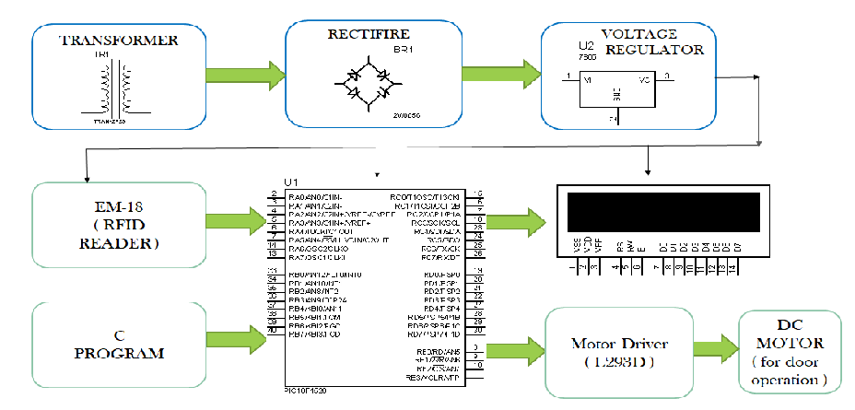

Fig 1. Block diagram

**Hardware used:**

1. **PIC18F4520 microcontroller**
2. **RFID reader ( EM-18 )module**
3. **RFID tag**
4. **LED’s Green and Red**
5. **LCD module**
6. **L293D Driver IC**
7. **Step down Transformer**
8. **Voltage Regulator 7805 & 7812**
9. **1N4007 Rectifier diode**
10. **Capacitor**
11. **Resistors**
12. **10K POT**
13. **Jumper wires**
14. **DC Motor 10 rpm**

**Software used:**

1. **MPlab software**
2. **Proteus**
3. **Pad to Pad**
4. **Circuit Diagram and working:**

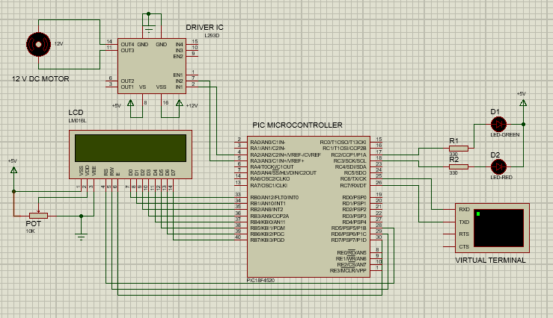

**Working:**

* When user brought the RFID tag in range of RFID reader, then electromagnetic coupling takes place between RFID reader and RFID tag and the RFID tag gets energized.
* The RFID reader reads information of RFID tag and send it to the microcontroller. After that microcontroller will check the information given by RFID reader and check it with the data stored in its memory.
* If the stored data matches with read data then it will send commands to display the message ACCESS GRANTED, Green LED gloves and gives High signal for actuating motor.
* If the stored data does not match with read data than it will send commands to display the message ACCESSS DENIED Red LED gloves and motor remain unactuated.

**Conclusion and further improvement:**

The above discussion shows that we have been able to implement and demonstrate a prototype of a RFID based security and secure the sensitive area with our module. RFID used which highly stable and reliable technology. RFID automatically detect the card is valid or not and do further process according to the validation of the tag.

**References**

[1] Datasheet TRF7960-61 Multi-Standard Fully Integrated 13.56-MHz Radio

Frequency Identification (RFID) Analog Front End and Data Framing Reader

System, Texas Instruments.

[2] Identification cards - Contactless integrated circuit(s) cards. Part 3: Anti-collision

And transmission protocol, Texas Instruments, March 2000

[3] Datasheet PIC18F2420/2520/4420/4520, Microchip.